Software Requirements Specification
for

Performance Optimization for Simulation of Computational Neural Network
Group No. 33

Prepared by Altaf Shaikh
Anuj Kamble
Pooja Kharade
Shashank Kuyate

Vishwakarma Institute Of Information Technology
17/09/2018
Table of Contents
Table of Contents ii
Revision History ii
1. Requirement Analysis 1
1.1 Purpose 1
1.2 Objectives 1
1.3 References 1
2. Functional Specifications 2
2.1 System Overview 3
2.2 User Classes and Characteristics 4
3. External Interface Requirements 5
3.1 User Interfaces 5
3.2 Application Programming Interfaces (APIs) 5
4. Technical Specifications 7
4.1 Hardware Details 7
4.2 Software details 7
4.3 Performance Constraints 7
4.2 Security Requirements 8
4.2 Software Quality Attributes 8
Appendix A: Glossary 9

Revision History
Name | Date | Reason For Changes | Version

Requirement Analysis

Purpose
The purpose of this document is to optimize the performance of the already developed sequential code to reduce the time complexity by using parallel computing. This project is useful for the scientists across the globe who wants to see the simulation in the olfactory neurons using computational neuroscience. The objective is to achieve faster, >=5 times more efficient code using OpenMP.

Objectives
The Objectives can be stated as:
- Modify the code to achieve performance optimization.
- Modifying to achieve openmp compatibility.
- Performance and benchmarkings.
- Final module consists of comparing the result pre and post optimization.
- Plotting the various performance graphs and studying the output.

References

List of web addresses and documents referred by this document:
- http://www.iiserpune.ac.in/~collins/insilico/index.html
- https://www.boost.org/
- https://www.boost.org/doc/libs/1_66_0/libs/numeric/odeint/doc/html/index.html
- https://www.openmp.org/
- http://headmyshoulder.github.io/odeint-v2/
- https://www.nvidia.com/docs/IO/116711/sc11-cuda-c-basics.pdf

Functional Specifications

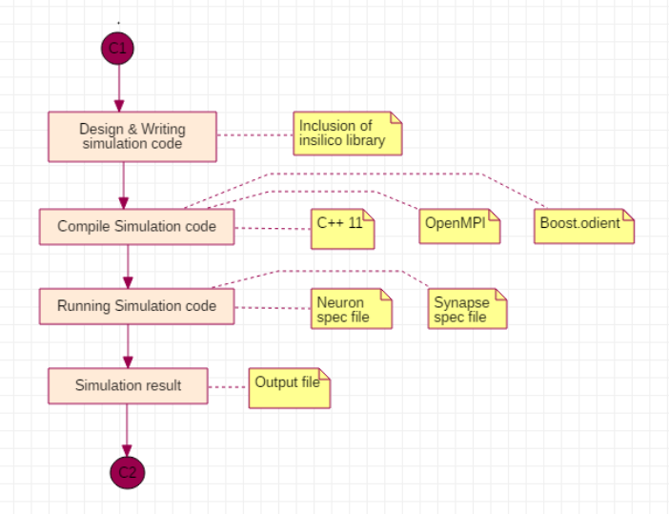
System Overview

Computational neuroscience is the field of study in which mathematical tools and theories are used to investigate brain function. It can also incorporate diverse approaches from electrical engineering, computer science and physics in order to understand how the nervous system processes information. The biophysical components of the neural network are represented in the form of ODE(Ordinary Differential equations). To convert any physical system into a mathematical model we need to have differential equation of it. insilico uses open source ODE integration library, Boost.odeint to efficiently solve problem related to computation, prominently integration. Running the simulation executable accepts runtime options for input and output files, giving out the simulation result into a specified output file.
  - User Classes and Characteristics
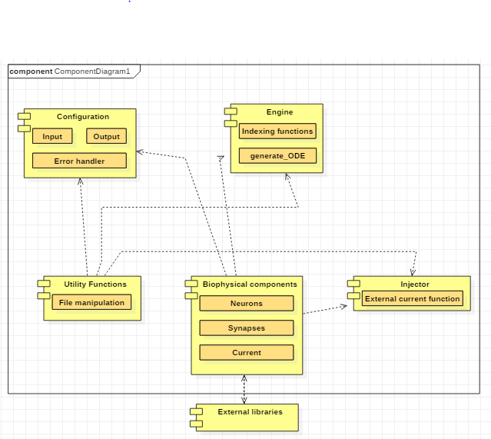

- Configuration
Configuration performs tasks related to efficient file handling and resource allocation and deallocation. File handling features such as read input files for simulation, creating and writing output file for simulation result, and opening and closing these files in all instances of successful and unsuccessful simulation completion.

Configuration has it’s own MPI support implementation. It does a job of distributing responsibilities among different MPI processes involved in reading and writing input and output files respectively.

- Engine
Engine is a runtime memory management and data handling unit. It is responsible for serving data required for simulation at runtime in the desired form. It generates the required ODEs(Ordinary Differential Equations). It has predefined set of API to understand Computational Neuroscience specific data and their relationships.
Engine also has it’s own MPI support. It plays a vital role of abstracting out the synchrony among the MPI processes during critical operations like data fetch and updates keeping data integrity and avoid data races.

- Biophysical Components
These includes the input files required for the simulation of the computational neural network. There are two input files. First file consists of the ‘initial condition’ (i.e initial values of all the variables of the neuron) and the second file consists of ‘connectivity’ (i.e initial values of all the variables of the synapse). They are in the Simulation Specification File format (ISF).

- Injector
Simulation can sometime pose a need for supply of external current at different level of requirements. For instance, an external pulse for few seconds, a constant DC, a spike of current for microseconds, and so on. All these needs can be satisfied by the Injector.

External Interface Requirements

User Interfaces
The interaction between the user and the system is done using the Command-line interface. In Ubuntu the following commands are used to build and execute the program.
Build (Compile):

Clone the source and run the following commands on terminal.
make SOURCE="path/to/source/file/with/main_function.cpp"

Execute:

Run the following command on terminal to execute the code.

./insilico.out -o <output_file>.csv -n <neuron_file.isf> -s <synapse_file.isf> -e <external_file.isfc>

Options:
-o Output file
-n Neuron configuration file
-s Synapse configuration file
-e External current configuration file (optional)

Application Programming Interfaces (APIs)

- Boost.odeint

. The biophysical components of the neural network are represented in the form of ODE(Ordinary Differential equations). To convert any physical system into a mathematical model we need to have differential equation of it. Neuronal simulation can be a memory and compute intensive problem. Computation intensive nature of problem is majorly due to integration of ordinary differential equations (ODEs) involved in the representation of dynamics of neuronal networks. insilico uses open source ODE integration library, Boost.odeint to efficiently solve problem related to computation, prominently integration.

- Insilico

Insilico is C++ library for Computational Neuroscience Simulation. Insilico is designed to address and fulfill Computational Neuroscience Simulation requirement and strives for keeping simulation writer focused on simulation details, without getting diverged due to several details of programming language.
To achieve this library provides an easy-to-use application programming interface (set of classes and functions, shortly API) to model and interact with biophysical components involved in simulation.

- OpenMP

An abbreviation for: Open Multi-Processing. It is an Application Program Interface (API), jointly defined by a group of major computer hardware and software vendors. OpenMP provides a portable, scalable model for developers of shared memory parallel applications. Provide capability to incrementally parallelize a serial program, unlike message-passing libraries which typically require an all or nothing approach

Technical Specifications

Hardware Details

Multi-core processor-

OpenMP is designed for multi-processor/core, shared memory machines. The OpenMP programming model provides a platform-independent set of compiler pragmas, directives, function calls, and environment variables that explicitly instruct the compiler how and where to use parallelism in the application.

Software Details

- Operation System - Ubuntu 11.04 +
- Programming Language used – C++ 11
- Software tools - Gprof
Gprof is a performance analysis tool for Unix applications. It used a hybrid of instrumentation and sampling^{[1]} and was created as an extended version of the older "prof" tool. Unlike prof, gprof is capable of limited call graph collecting and printing.

Performance Constraints
Design and implementation constraints of the project are as follows:
- Integration methodology –
The Insilico library file uses two methods for the integration purpose i.e. RK4 method and Euler method. Both of the methods involves their own assumptions so that will cause some deviation with the original result and the shown output.

- Real Time Dataset –
The dataset which is been available is obtained from the scientists working across the globe on the basis of their experiments. So there is always some deviation in real time data, that data cannot be 100% accurate.

Security Requirements
It is necessary to test the system at every stage to assure its speed and accuracy of the simulations provided.
This would approve good quality of the final framework delivered.

Software Quality Attributes
- Adaptability: The algorithm should adapt itself efficiently and fast to changed conditions
- Correctness: The results shown by the enhanced code should not be much deviated from the original result from the sequential code
- Maintainability: Scientists should maintain the collected records form different neurons
- Usability: The project satisfy the scientists’ needs
- Portability :Portable across three major platforms (Linux, Mac OS, Windows)
- Understandability: Easy to understand API

Appendix A: Glossary
- Computational Neuroscience - Computational neuroscience is the field of study in which mathematical tools and theories are used to investigate brain function. It can also incorporate diverse approaches from electrical engineering, computer science and physics in order to understand how the nervous system processes information.

- Neuron - A neuron (also called neurone or nerve cell) is a cell that carries electrical impulses. Neurons are the basic units of the nervous system and its most important part is the brain.

- Synapse - In the nervous system, a synapse is a structure that permits a neuron (or nerve cell) to pass an electrical or chemical signal to another neuron or to the target effector cell.
- Benchmark - In computing, a benchmark is the act of running a computer program, a set of programs, or other operations, in order to assess the relative performance of an object, normally by running a number of standard tests and trials against it.^{[1]} The term benchmark is also commonly utilized for the purposes of elaborately designed benchmarking programs themselves. Benchmarking is usually associated with assessing performance characteristics of computer hardware, for example, the floating point operation performance of a CPU, but there are circumstances when the technique is also applicable to software. Software benchmarks are, for example, run against compilers or database management systems (DBMS). Benchmarks provide a method of comparing the performance of various subsystems across different chip/system architectures.
- MPI - Message Passing Interface (MPI) is a standardized and portable message-passing standard designed by a group of researchers from academia and industry to function on a wide variety of parallel computing architectures. The standard defines the syntax and semantics of a core of library routines useful to a wide range of users writing portable message-passing programs in C, C++, and Fortran. There are several well-tested and efficient implementations of MPI, many of which are open-source or in the public domain. These fostered the development of a parallel software industry, and encouraged development of portable and scalable large-scale parallel applications.

